Lab-04

**Instructor:**

**Table Create:**

CREATE TABLE `instructor` ( `Id` varchar(30), `Name` varchar(30),`Dept_Name` varchar(30),`Salary` int(30) );

**Table data input:**

INSERT INTO `instructor` (`Id`, `Name`, `Dept_Name`, `Salary`) VALUES

('10101', 'Srinivasan', 'CSE', 65000),

('12121', 'Wu', 'FIN', 90000),

('15151', 'Mozart', 'Music', 40000),

('22222', 'Einstein', 'Physics', 50000),

('32343', 'Said', 'History', 60000),

('33456', 'Gold', 'Physics', 87000),

('45555', 'Katz', 'CSE', 75000),

('58583', 'Cali', 'History', 62000),

('76543', 'Singh', 'FIN', 80000),

('76766', 'Crick', 'Bio', 72000),

('83821', 'Brandt', 'CSE', 92000),

('98345', 'Kin', 'EEE', 80000);

**Teaches:**

**Table create:**

CREATE TABLE `teaches` (`Id` varchar(30),`C_Id` varchar(30,`Section_Id` int(10));

**Table data input:** INSERT INTO `teaches` (`Id`, `C_Id`, `Section_Id`) VALUES ('10101', 'CSE_101', 1), ('12121', 'CSE_111', 2),('13131', 'CSE_311', 3);

Q1.Perform Cartesian Product Operation between these two relation.

[SELECT](http://localhost/phpmyadmin/url.php?url=https://dev.mysql.com/doc/refman/8.0/en/select.html) * FROM instructor,teaches;

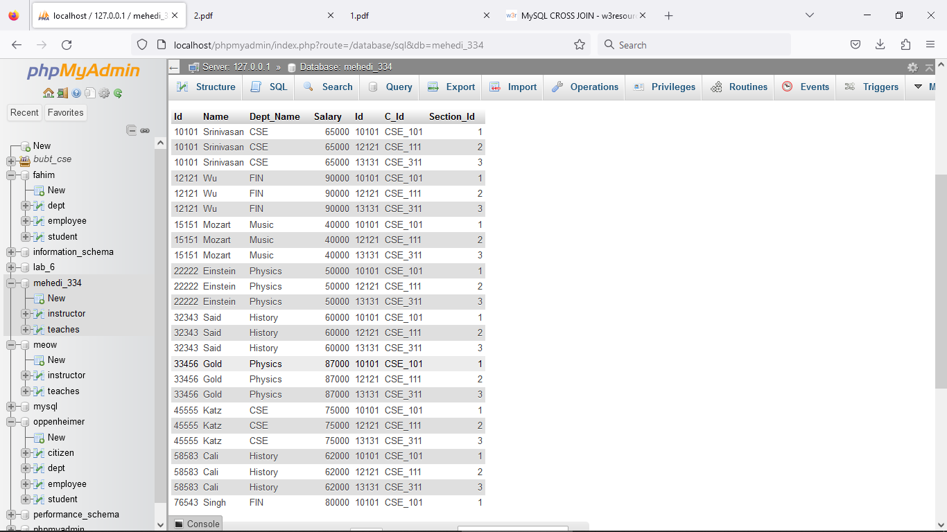

Q2. Find those instructors who teaches any of the courses.

[SELECT](http://localhost/phpmyadmin/url.php?url=https://dev.mysql.com/doc/refman/8.0/en/select.html) Name FROM instructor,teaches WHERE instructor.Id=teaches.Id;

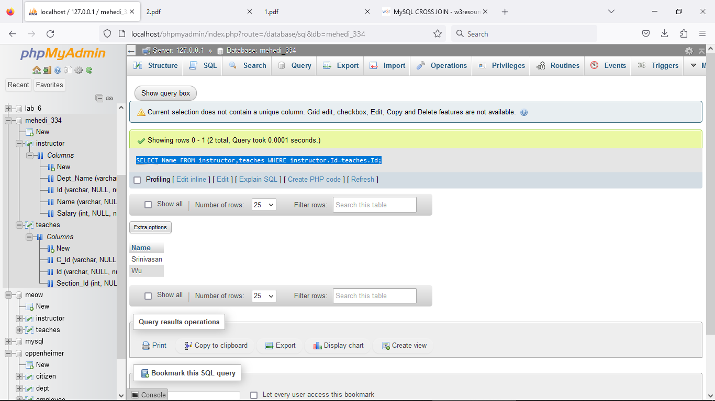

Q3. Find only instructor names and course id for instructors in the Computer Science

department.

[Select](http://localhost/phpmyadmin/url.php?url=https://dev.mysql.com/doc/refman/8.0/en/select.html) Name,instructor.Id from instructor INNER JOIN teaches where instructor.Id=teaches.Id [AND](http://localhost/phpmyadmin/url.php?url=https://dev.mysql.com/doc/refman/8.0/en/logical-operators.html%23operator_and) Dept_Name= 'CSE';

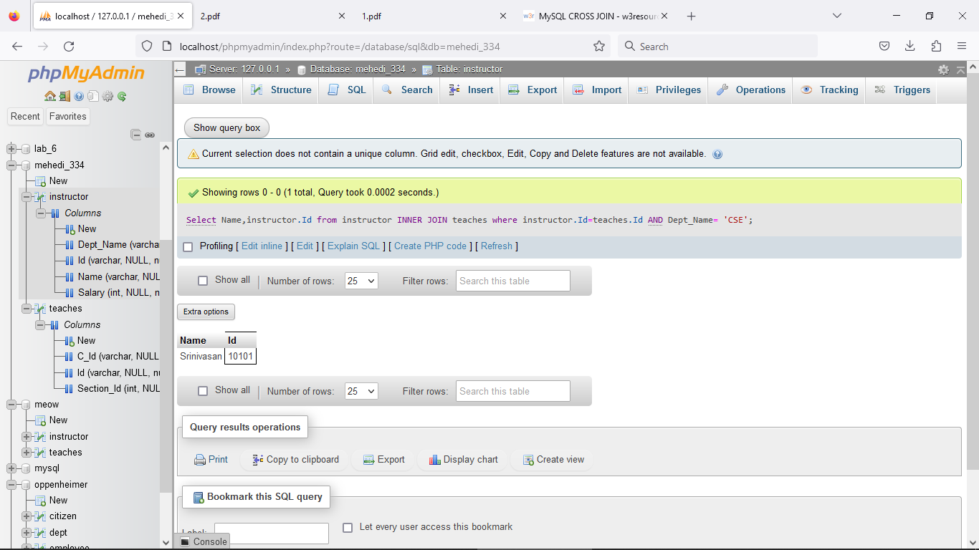

Q4. Find the total no. of tuples in “Instructor” relation.

[SELECT](http://localhost/phpmyadmin/url.php?url=https://dev.mysql.com/doc/refman/8.0/en/select.html) [COUNT](http://localhost/phpmyadmin/url.php?url=https://dev.mysql.com/doc/refman/8.0/en/aggregate-functions.html%23function_count)(*) FROM instructor;

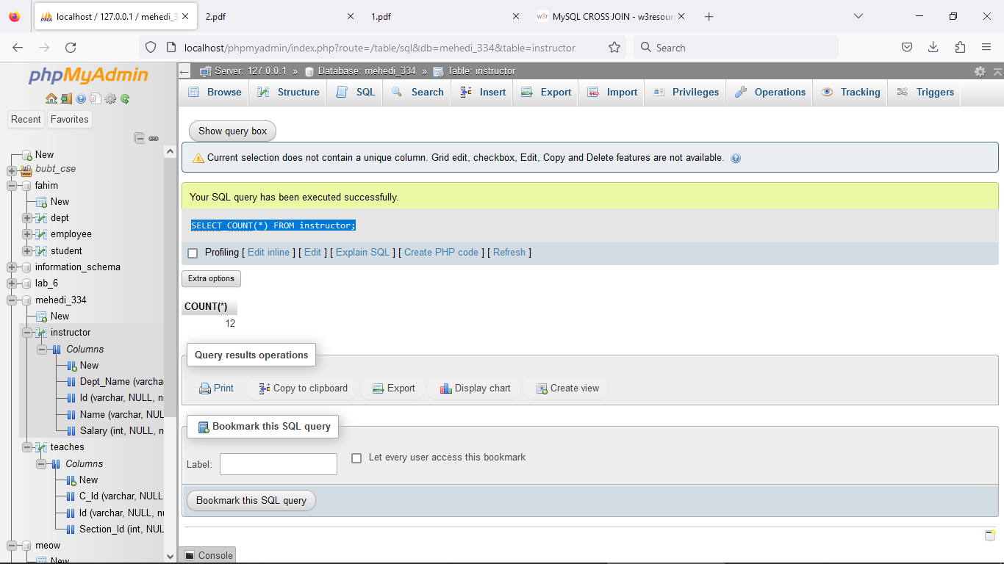

Q5. Answer Q2 using Natural Join.

[SELECT](http://localhost/phpmyadmin/url.php?url=https://dev.mysql.com/doc/refman/8.0/en/select.html) * FROM instructor NATURAL JOIN teaches;

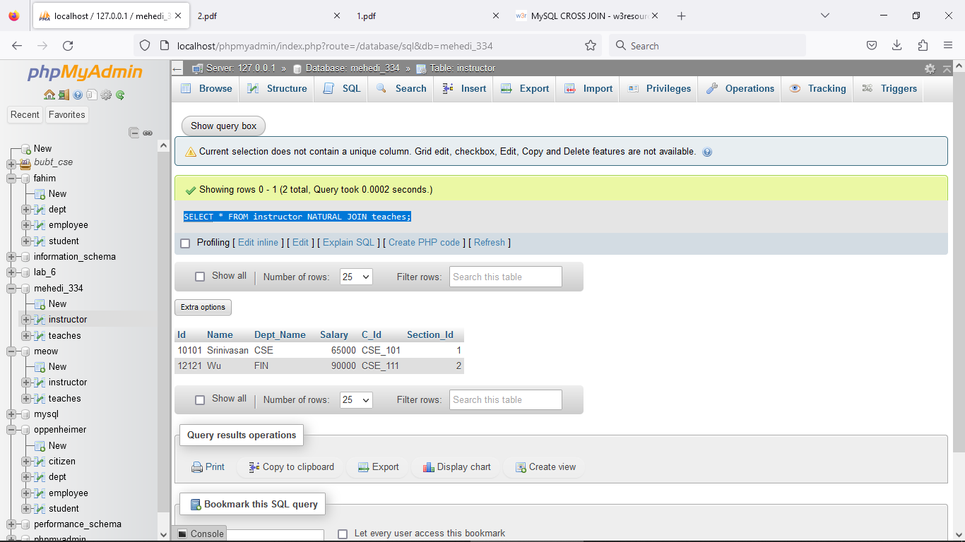

Q6. Perform Left Outer Join.

[SELECT](http://localhost/phpmyadmin/url.php?url=https://dev.mysql.com/doc/refman/8.0/en/select.html) * FROM instructor NATURAL [LEFT](http://localhost/phpmyadmin/url.php?url=https://dev.mysql.com/doc/refman/8.0/en/string-functions.html%23function_left) OUTER JOIN teaches;

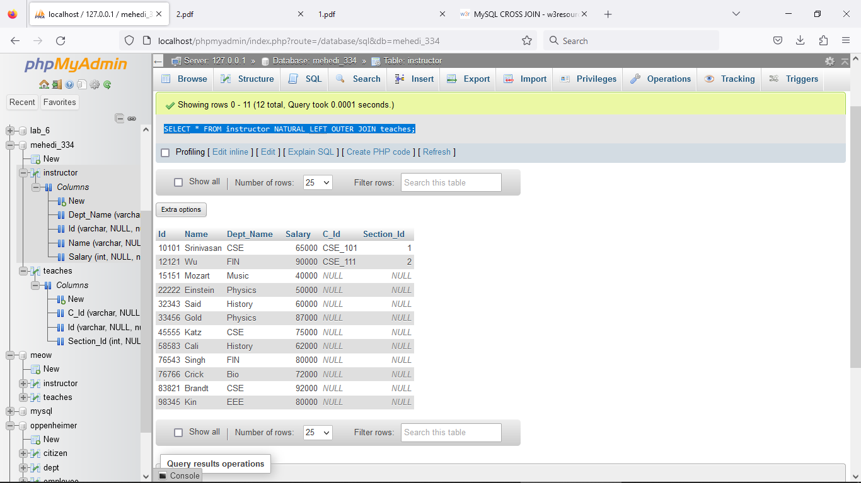

Q7. Perform Right Outer Join.

[SELECT](http://localhost/phpmyadmin/url.php?url=https://dev.mysql.com/doc/refman/8.0/en/select.html) * FROM instructor NATURAL [RIGHT](http://localhost/phpmyadmin/url.php?url=https://dev.mysql.com/doc/refman/8.0/en/string-functions.html%23function_right) OUTER JOIN teaches;

